

PANGANI GIRLS’ KCSE PREDICTION
EXAM TEST-2025
231/1
BIOLOGY
THEORY
PAPER 1
TIME: 2 HOURS

NAME…………………………………………………………………………………………
SCHOOL………………………………………………. SIGN……………………..
INDEX NO ……………………………………………. DATE…………………….

Kenya Certificate of Secondary Education.

INSTRUCTIONS TO CANDIDATES
- Write your name and Index Number in the spaces provided above.
- Sign and write date of examination in the spaces provided above.
- Answer ALL questions in the spaces provided.
- All workings must be clearly shown where necessary.

FOR EXAMINERS USE ONLY.
Question | Maximum Score | Candidates Score
1 – 25 | 80

Answer ALL questions in the spaces provided.
- Explain the term Binomial Nomenclature. (1mk)
……………………………………………………………………………………………………
……………………………………………………………………………………………………

- Name three forces involved in transportation of water and mineral salts. (3mks)
……………………………………………………………………………………………………
……………………………………………………………………………………………………
……………………………………………………………………………………………………

- (a) Give two roles of DNA. (2mks)
……………………………………………………………………………………………………
……………………………………………………………………………………………………

(b) State the difference between DNA and RNA. (1mk)
……………………………………………………………………………………………………
……………………………………………………………………………………………………
……………………………………………………………………………………………………

- Two strips A and B were cut from Tradescantia whose cell sap was 30% sugar. Strip A was placed in a solution of 10% sugar concentration while strip B was placed in 50% sugar concentration.
    - What change was expected in strips A and B? (2mks)
Strip A:
……………………………………………………………………………………………………
……………………………………………………………………………………………………

Strip B:
……………………………………………………………………………………………………
……………………………………………………………………………………………………

    - Account for the results in strip A. (3mks)
……………………………………………………………………………………………………
……………………………………………………………………………………………………
……………………………………………………………………………………………………
……………………………………………………………………………………………………
……………………………………………………………………………………………………

- State the biological significance of each of the following:
    - Thick muscular walls and narrow lumen in arteries. (1mk)
……………………………………………………………………………………………………
……………………………………………………………………………………………………
    - Narrow xylem vessels in flowering plants. (1mk)
……………………………………………………………………………………………………
……………………………………………………………………………………………………

- Suggest three reasons why green plants are included in a fish aquarium. (3mks)
……………………………………………………………………………………………………
……………………………………………………………………………………………………
……………………………………………………………………………………………………
……………………………………………………………………………………………………
……………………………………………………………………………………………………

- (a) Study the diagram below and answer the questions that follow.
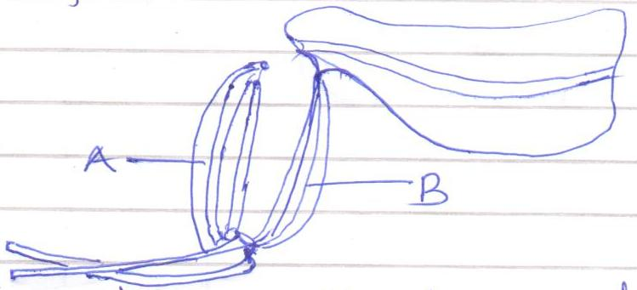

      - Name the muscle labelled: (2mks)
A:…………………………………………………………………………………….
B:…………………………………………………………………………………….

      - What happens to each muscle as the arm is straightened? (2mks)
……………………………………………………………………………………………………
……………………………………………………………………………………………………
……………………………………………………………………………………………………

- The binomial name of housefly is MUSCA DOMESTICA.
      - State two mistakes in the way the scientific name is written. (2mks)
……………………………………………………………………………………………………
……………………………………………………………………………………………………

      - Re-write the name in correct manner following the rules of binomial nomenclature.(1mk)
……………………………………………………………………………………………………

- The diagram below shows the general appearance of lactic acid in the blood of an athlete after an exercise. Study it carefully and answer the questions that follow:

50

` 40
S
Lactic acid concentration cm
30

20
R T
10

0 2 4 6 8 10 12 14 16 18 Time

(a) Name the physiological process represented by the above diagram. (1mk)
……………………………………………………………………………………………………

- Explain what happened in the body between points:
  - R and S (1mk)
……………………………………………………………………………………………………
……………………………………………………………………………………………………

  - S and T (1mk)
……………………………………………………………………………………………………
……………………………………………………………………………………………………

- State the use of each of the following apparatus:
      - Bait trap (1mk)
……………………………………………………………………………………………………

      - Specimen bottle (1mk)
……………………………………………………………………………………………………

      - Pitfall trap (1mk)
……………………………………………………………………………………………………

- (a) Define the term organic evolution. (1mk)
……………………………………………………………………………………………………
……………………………………………………………………………………………………
……………………………………………………………………………………………………

(b) Give two examples of vestigial structures. (2mks)
……………………………………………………………………………………………………
……………………………………………………………………………………………………
……………………………………………………………………………………………………

- (a) Distinguish between epigeal and hypogeal germination. (1mk)
……………………………………………………………………………………………………
……………………………………………………………………………………………………
……………………………………………………………………………………………………

(b) Why is oxygen necessary in the germination of seeds? (2mks)
……………………………………………………………………………………………………
……………………………………………………………………………………………………
……………………………………………………………………………………………………

- (a) Digestion in the stomach involves the gastric juice, which contains mucus as one of its components. State the role of mucus in the digestion process. (1mk)
……………………………………………………………………………………………………
……………………………………………………………………………………………………

(b) Give two adaptations of ileum to its functions. (2mks)
……………………………………………………………………………………………………
……………………………………………………………………………………………………
……………………………………………………………………………………………………

- The diagram below represents a stage during cell division.
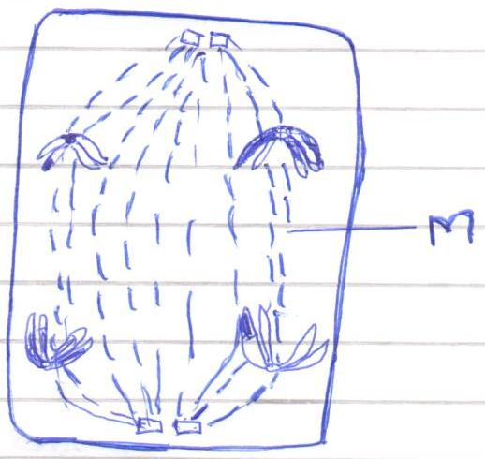

    - (i) Identify the stage of cell division. (1mk)
……………………………………………………………………………………………………

(ii) Give two reasons for your answer to (a) (i) above. (2mks)
……………………………………………………………………………………………………
……………………………………………………………………………………………………
……………………………………………………………………………………………………

    - Name the structure labelled M. (1mk)
……………………………………………………………………………………………………

- Explain why amoeba cannot burst when placed in hypertonic solution. (2mks)
……………………………………………………………………………………………………
……………………………………………………………………………………………………
……………………………………………………………………………………………………

(a) Name the organelle that is involved in each manufacture of Lipids. (1mk)
……………………………………………………………………………………………………

(b) State three functions of Golgi apparatus. (3mks)
……………………………………………………………………………………………………
……………………………………………………………………………………………………
……………………………………………………………………………………………………
……………………………………………………………………………………………………

- Give the functions of the following parts of human eye:
(a) Lens (1mk)
……………………………………………………………………………………………………
……………………………………………………………………………………………………

(b) Ciliary body. (1mk)
……………………………………………………………………………………………………
……………………………………………………………………………………………………
(c) Cornea (1mk)
………………………………………………………………………………………………
………………………………………………………………………………………………

- A shoot of seedling exposed to light on one side bends towards the source of light as it grows.
    - Name the response exhibited by the shoot of the seedling. (1mk)
……………………………………………………………………………………………………

    - Explain how the bending towards the source of light occurs. (3mks)
……………………………………………………………………………………………………
……………………………………………………………………………………………………
……………………………………………………………………………………………………
……………………………………………………………………………………………………

- The chart below show s a feeding relationship in a certain eco-system.
Grasshopper Lizards Snakes

Green Plants Hawks

Mice Domestic cats
    - Construct two food chains ending with a tertiary consumer in each case. (2mks)

    - Name one secondary consumers in the food web. (1mk)
……………………………………………………………………………………………………

- State the functions of the following parts of a nephron.
(i) Loop of henle (1mk)
……………………………………………………………………………………………………
(ii) Distal convoluted tubule (1mk)
……………………………………………………………………………………………………

- A flower was found to have the following characteristics:
- Inconspicuous petals
- Long feathery stigma
- Small, light pollen grains
    - What is the likely agent of pollination of the flower? (1mk)
……………………………………………………………………………………………………

    - What is the significance of the long feathery stigma in the flower? (1mk)
……………………………………………………………………………………………………
……………………………………………………………………………………………………

- Explain how the following factors determine the daily energy requirement in humans.
    - Age (1mk)
……………………………………………………………………………………………………
……………………………………………………………………………………………………

    - Occupation (1mk)
……………………………………………………………………………………………………
……………………………………………………………………………………………………

    - Sex (1mk)
……………………………………………………………………………………………………
……………………………………………………………………………………………………

- Study the diagram below and answer the questions that follow.
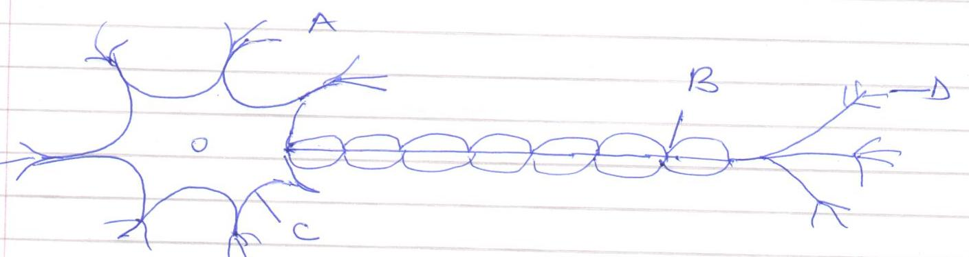
    - Name the parts labelled:- (3mks)
A: ………………………………………………..
C: ………………………………………………..
D: ………………………………………………..

    - State the function of part labelled B. (1mk)
………………………………………………………………………………………………
………………………………………………………………………………………………

- Most terrestrial plants do not grow well in water-logged soils. Give a reason for this.
(1mk)
……………………………………………………………………………………………………
……………………………………………………………………………………………………
……………………………………………………………………………………………………

- State the mode of a sexual reproduction exhibited by the following organisms:
      - Yeast (1mk)
……………………………………………………………………………………………………

      - Mushroom (1mk)
……………………………………………………………………………………………………
……………………………………………………………………………………………………

- Give reasons for each of the following:
(a) Constant body temperature is maintained in mammals. (2mks)
……………………………………………………………………………………………………
……………………………………………………………………………………………………
……………………………………………………………………………………………………

(b) Low blood sugar level is harmful to the body. (1mk)
……………………………………………………………………………………………………
……………………………………………………………………………………………………

- (a) Explain what is meant by a test-cross as used in genetics. (1mk)
……………………………………………………………………………………………………
……………………………………………………………………………………………………

(b) Determine the probability of a couple with blood group AB getting a child with blood group B. (Show your working).

- Name the end products of the light stage of photosynthesis. (2mks)
……………………………………………………………………………………………………
……………………………………………………………………………………………………
……………………………………………………………………………………………………

